Neural network:
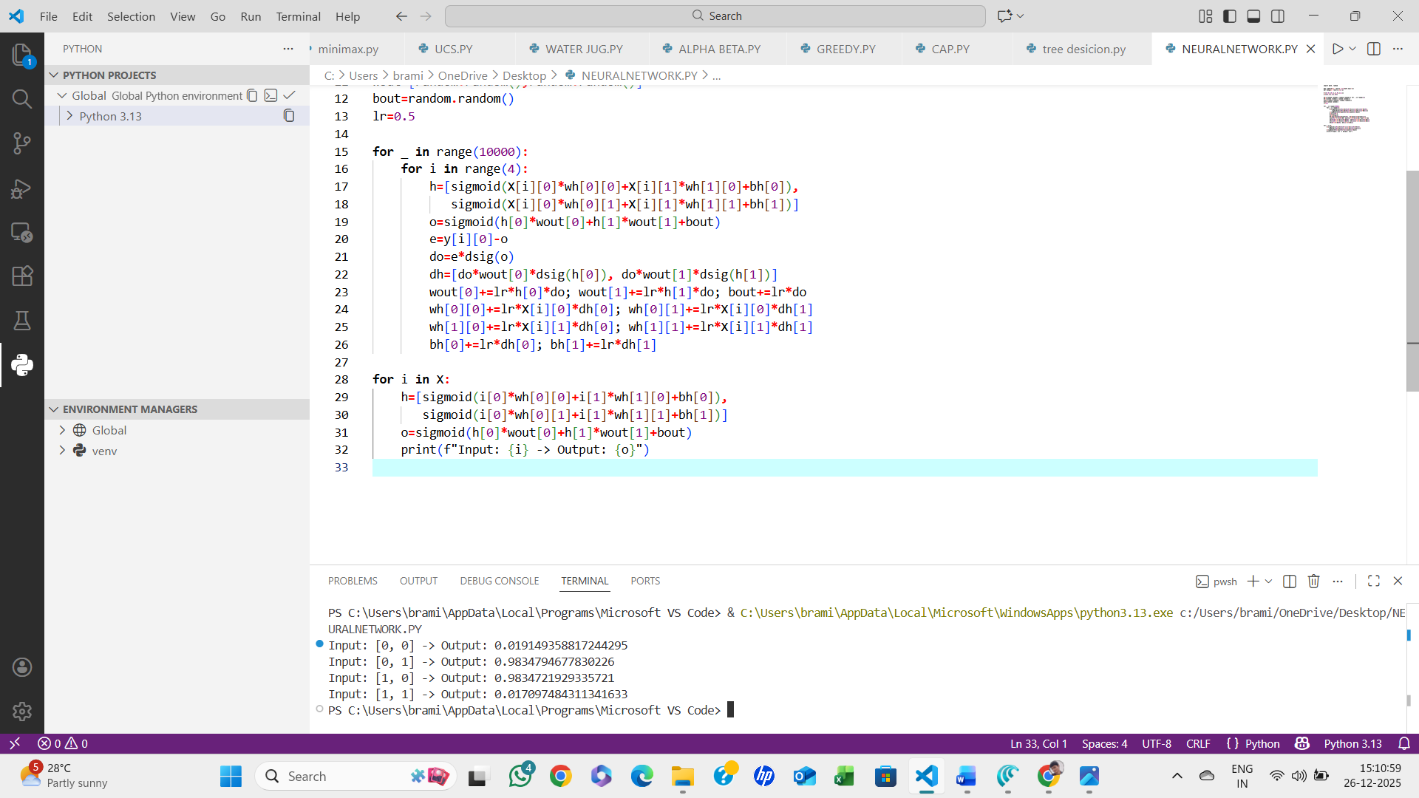
Algorithm:
- Initialize weights and bias randomly
- Take input values
- Compute weighted sum
- Apply activation function
- Compare output with target
- Calculate error
- Update weights using learning rule
- Repeat steps until error is minimized
- Stop.

